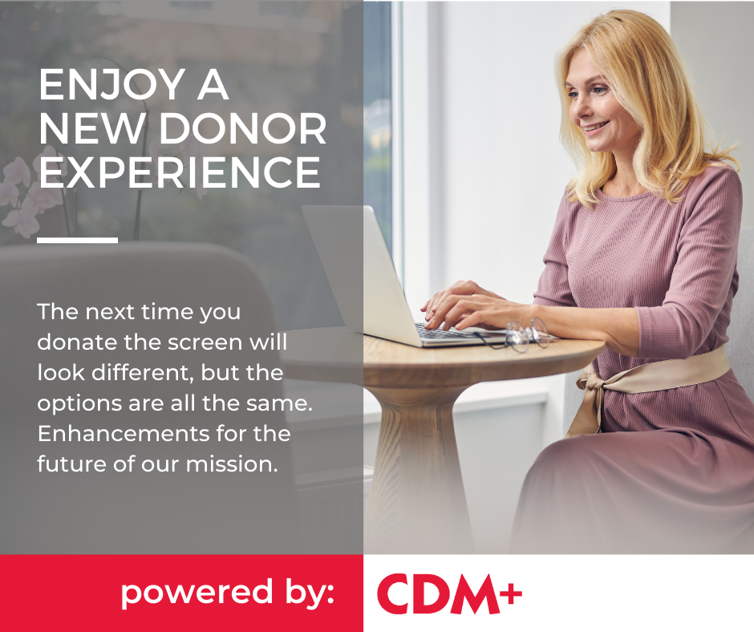

Our donors mean the world to us and we very much value your loyalty and support. Without you our mission cannot be realized. With that in mind, we wanted to share some exciting news. We are moving to a new donor and donation platform powered CDM+. Our previous provider, Stewardship, will still be processing your donation so there will be no change to recurring gifts. This change allows us to be more efficient and effective with our internal operations and with you, our donors.

You will see a change in our donation page, but everything behind the scenes, like your user name and password, are all still valid. You will still be able to choose what fund you would like to donate to, and choose a credit card or ACH donation, just like before. You will receive your immediate email donation receipt from us and your year-end tax receipt. No cons…just pros. In short, you don’t need to do anything for this change—just enjoy an upgraded donation experience!

We of course pride ourselves on being good stewards of your donations and CDM+, along with Stewardship, has provided an economical solution to meets our needs. We even have room to grow into the future.

Thank you again for your continued support. Now, onward with CDM+!

